D’Leonor’s Point of Sale is a system that helps the staffs in the company to operate the ticketing for the resort’s entrance, pools, and rides. It also has an admin side that enables the admin to view the sales revenue for the past days, months, and/or years.

***Getting Started Prerequisites***

What things you need to install the software and how to install them WAMP (Apache, MySQL) Installing

1. Download the WAMP from the site below

<https://sourceforge.net/projects/wampserver/>

1. Click the Download button
2. Choose between 32-bit or 64-bit
3. Install WAMP Built with

* Sublime - The web framework used
* WAMP - Used for the database Versioning
* We use GitHub for versioning. For the versions available, see the tags on thisrepository.

<https://github.com/jayneejdc/D-LeonorPOS_MajorProject>

**USER INTERFACE**

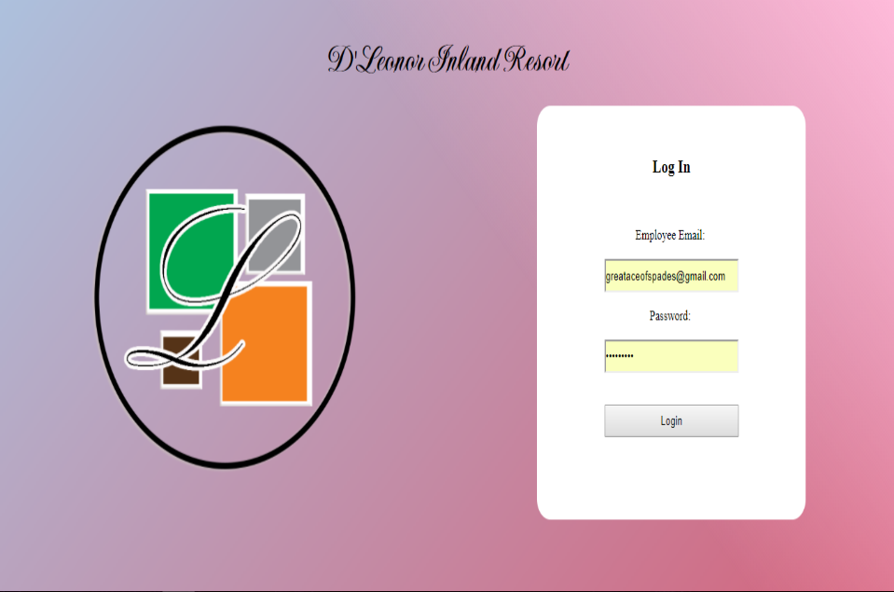Log-In

First, the user must log-in. This page requires the user/s username and password in order to have access to the contents of the site. The system will check whether the account type is a user or a master/admin.

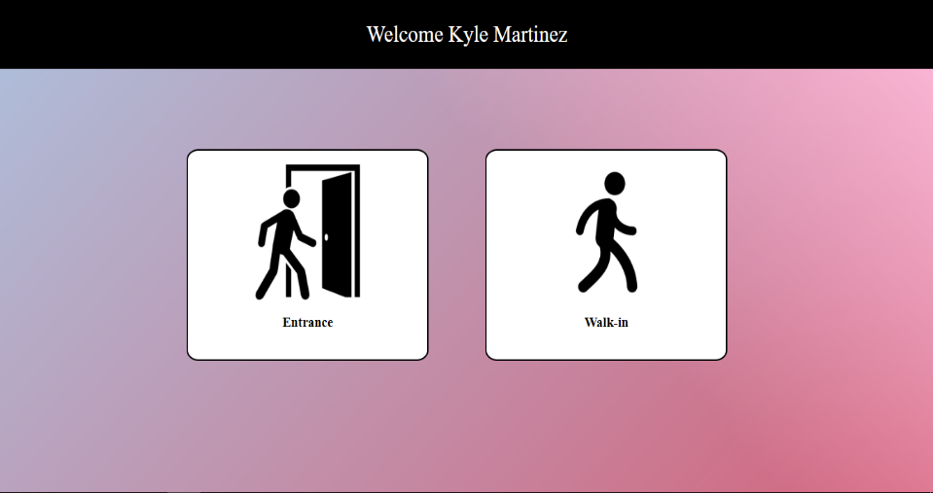Welcome

After logging-in, the user will be directed to the welcome page. Wherein, the user will choose whether the guest/s or customer/s are form the entrance or just a walk-in. Walk-in means that they are already inside the resort and they just want to have additional tickets of some amenities that they wanted to add.

Entrance

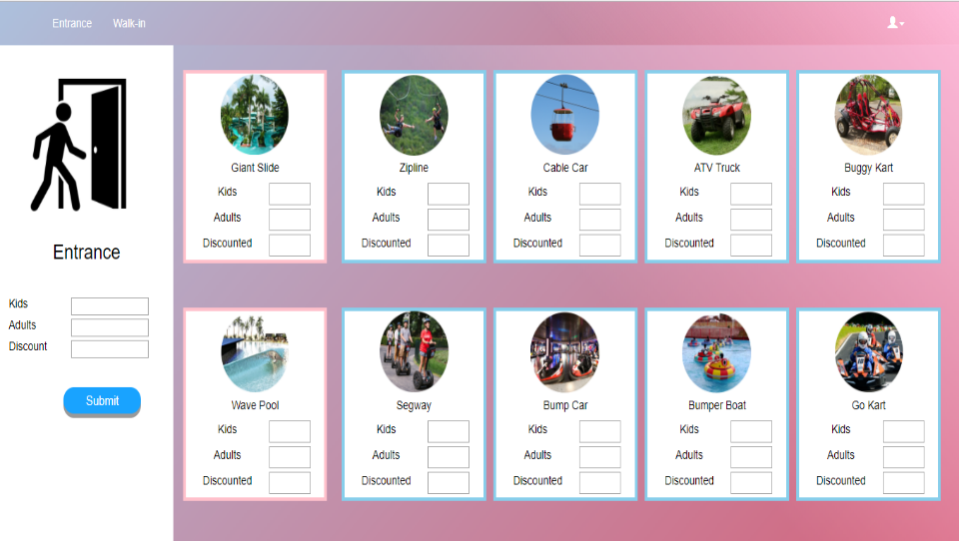

If the user/staff chose ‘Entrance’, the staff must input how many entrance tickets for the adults, kids, and/or discounted. While for the rides and pools, it is optional whether the customer wants to buy some tickets for those amenities or not. Then click ‘Submit’.

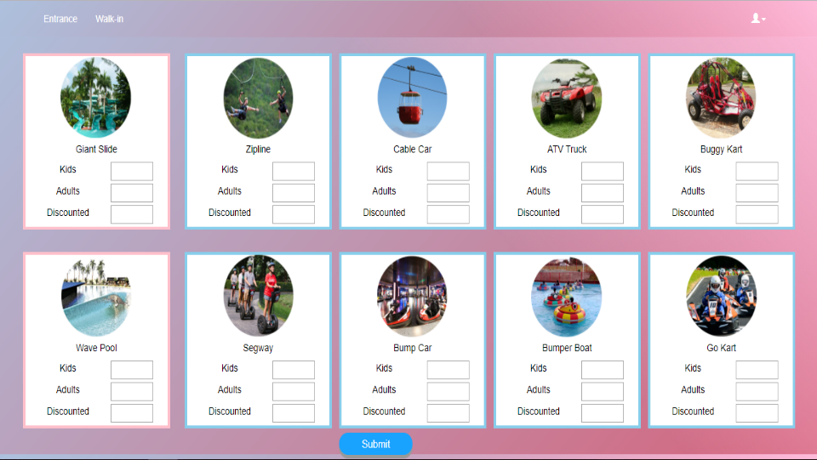Walk-In

If the user/staff chose ‘Walk-In’, the staff must input how many tickets for the pool/s and/or ride/s for the adults, kids, and/or discounted. Then click ‘Submit’. This option is for those who are already inside the resort and just want to add some more amenities/activities.

Receipt

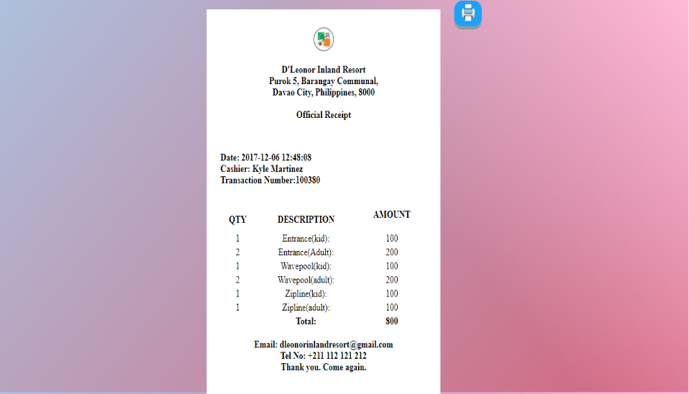

After submitting the transaction, the staff will be directed to the receipt page. Wherein the staff will print the receipt and the tickets that the customer had bought.

**ADMIN INTERFACE**

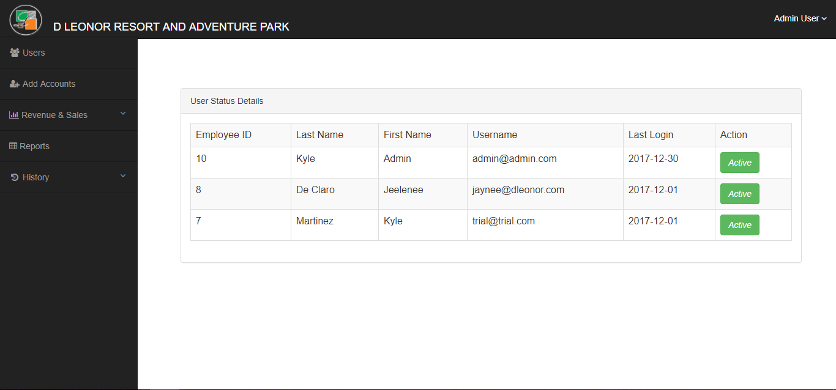Users

After logging in, the admin will be directed to the accounts page. Wherein, the admin can view who are the employees that has accounts and whose accounts are activated and deactivated.

Add Account

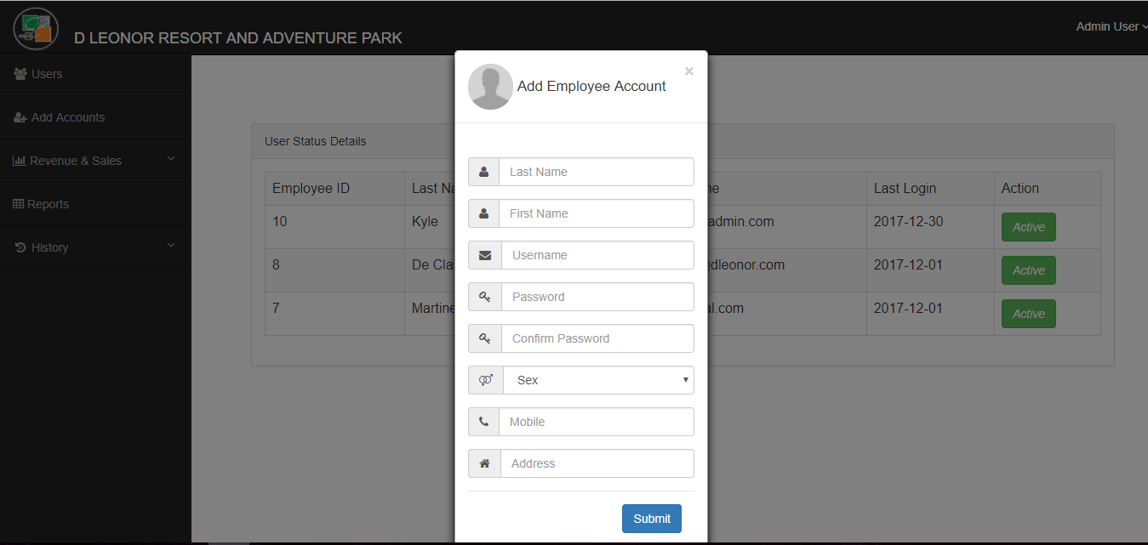

The admin is the only one who has the authority to create and account for the employees / staffs. This is the fill-up form in creating an account.

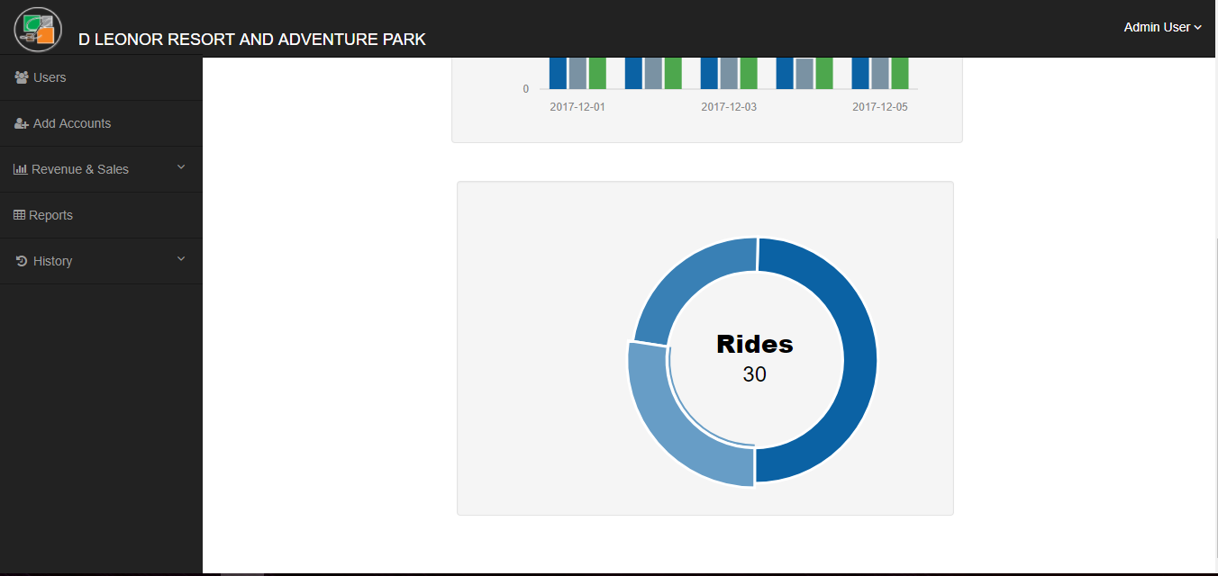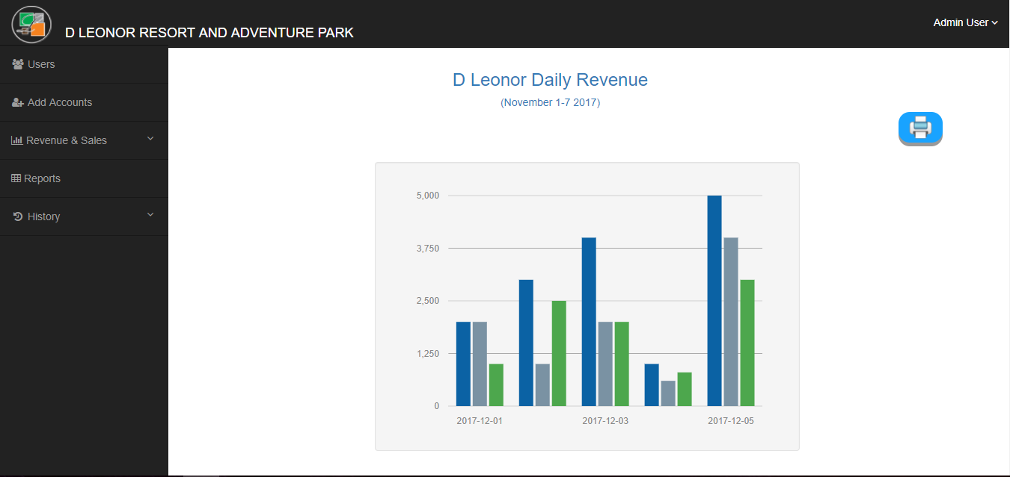Revenue & Sales

Revenue Sales is divided into 4 categories: Daily, Weekly, Monthly, and Yearly. In each category, graphs for provided as a representation for the data of the revenue and the sales.

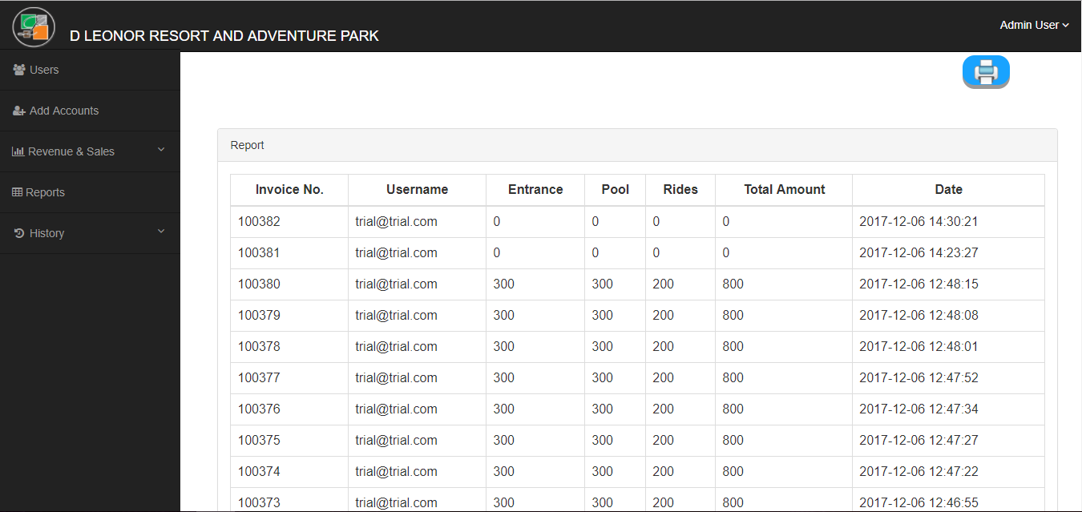Reports

In the reports page, the admin can view the transactions completed and the total amounts being paid and who operated the transactions.

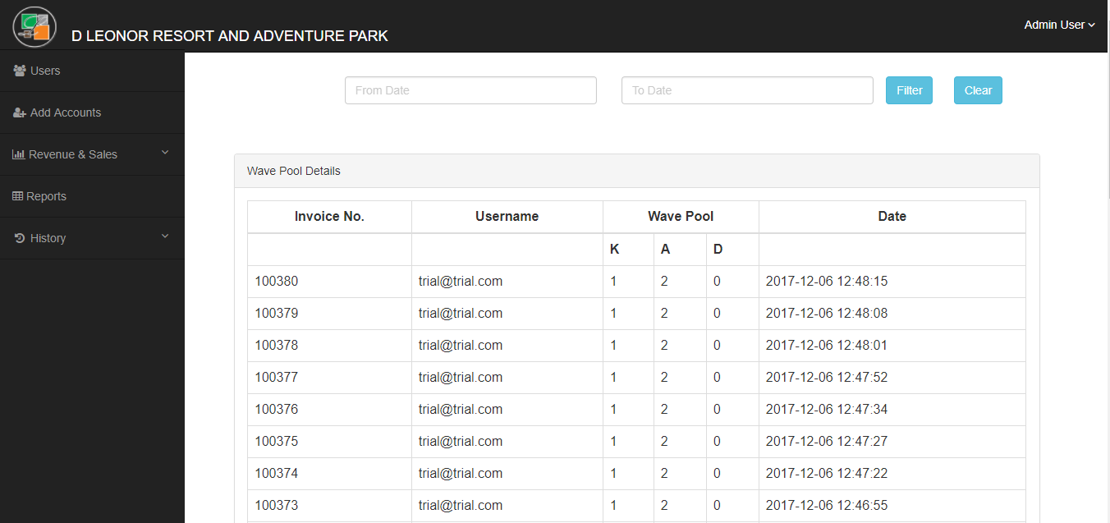History

Another one is the history. Wherein, the admin can view the invoice number, date, and the number of tickets that was ordered in each amenity.

***Authors***

• Coquilla, Angelica B.

• De Claro, Jeelenee Jayson L.

• Martinez, Kyle Matthew C.

***Acknowledgments***

• W3schools

• Bootstrap

• PDF`s for documentation